ITDI110 - Object-Oriented Programming & Software Development
WEEK 9 PRACTICAL LAB
JSON, Serialization and Deserialization
Student Course Registration Application

1. Lab Scenario
A university requires a responsive Student Course Registration application. The application will collect student details, validate them using regular expressions, create a Student object, convert the object into JSON text using JSON.stringify(), convert the JSON text back into JavaScript data using JSON.parse(), and display the effect of each conversion directly on the webpage. In this revised lab, the application is also organised using separate Model, View and Controller JavaScript files.

2. Learning Outcomes
- Apply OOP using a Student class, constructor, properties and methods.
- Organise a JavaScript application using separate Model, View and Controller files.
- Use Regular Expressions to validate Student ID, student name, email and phone number.
- Use events and callbacks to respond to form submission.
- Represent structured data using a nested object and an array.
- Use JSON.stringify() to serialize a JavaScript object into JSON text.
- Use JSON.parse() to deserialize JSON text back into JavaScript data.
- Compare the original object, serialized JSON string and parsed JavaScript object.
- Generate and download registered student data as students.json.

3. Application Flow
Student enters registration details
|
v
Regular Expression Validation
|
v
CONTROLLER receives form data
|
v
MODEL: new Student(...) creates class instance
|
v
JSON.stringify(student)
|
v
JSON STRING / TEXT displayed by VIEW
|
v
JSON.parse(jsonString)
|
v
PARSED JAVASCRIPT OBJECT displayed by VIEW
|
v
Registered student displayed

4. Project Setup - Separate HTML, CSS and MVC JavaScript
Follow these instructions carefully before writing any code.
- Create a new folder on your computer named student-registration_lab9.
- Open Visual Studio Code.
- Select File > Open Folder.
- Select the student-registration_lab9 folder and click Select Folder.
- In the Explorer panel, create three folders named html, css and js.
- Inside the js folder, create three folders named model, view and controller.
- Inside html, create a file named index.html.
- Inside css, create a file named style.css.
- Inside js/model, create a file named Student.js.
- Inside js/view, create a file named StudentView.js.
- Inside js/controller, create a file named StudentController.js.
- Confirm that your folder structure matches the structure below.
student-registration_lab9/
|
|-- html/
| `-- index.html
|
|-- css/
| `-- style.css
|
`-- js/
|-- model/
| `-- Student.js
|
|-- view/
| `-- StudentView.js
|
`-- controller/
`-- StudentController.js

5. Complete HTML File - html/index.html
Open html/index.html. Copy and paste the complete script below, then press Ctrl+S to save.
<!DOCTYPE html>
<html lang="en">
<head>
<meta charset="UTF-8">
<meta name="viewport" content="width=device-width, initial-scale=1.0">
<title>Student Course Registration</title>

<!-- index.html is inside html/, so go up one level to css/ -->
<link rel="stylesheet" href="../css/style.css">
</head>

<body>

<header>
<h1>Student Course Registration</h1>
<p>Week 9 - JSON Serialization and Deserialization</p>
</header>

<main class="container">

<section class="card">
<h2>1. Enter Student Details</h2>

<form id="studentForm">

<label for="studentID">Student ID</label>
<input type="text" id="studentID" placeholder="STU001" required>
<small id="studentIDError" class="error"></small>

<label for="studentName">Student Name</label>
<input type="text" id="studentName" placeholder="Mary Tari" required>
<small id="nameError" class="error"></small>

<label for="email">Email</label>
<input type="text" id="email" placeholder="mary@example.com" required>
<small id="emailError" class="error"></small>

<label for="phone">Phone Number</label>
<input type="text" id="phone" placeholder="7712345" required>
<small id="phoneError" class="error"></small>

<label for="island">Island</label>
<input type="text" id="island" placeholder="Efate" required>

<label for="province">Province</label>
<select id="province" required>
<option value="">Select Province</option>
<option value="Torba">Torba</option>
<option value="Sanma">Sanma</option>
<option value="Penama">Penama</option>
<option value="Malampa">Malampa</option>
<option value="Shefa">Shefa</option>
<option value="Tafea">Tafea</option>
</select>

<label>Select Courses</label>

<div class="courses">
<label>
<input type="checkbox" name="course" value="ITDI110">
ITDI110 - Object-Oriented Programming
</label>

<label>
<input type="checkbox" name="course" value="ITDI111">
ITDI111 - Databases
</label>

<label>
<input type="checkbox" name="course" value="ITDI112">
ITDI112 - Web Development
</label>
</div>

<small id="courseError" class="error"></small>

<button type="submit">Register and Convert</button>
</form>

<p id="message"></p>
</section>

<section class="card">
<h2>2. Original Student Object</h2>
<p>This shows the data stored in the Student object before JSON.stringify().</p>
<pre id="objectOutput">No student object yet.</pre>
</section>

<section class="card">
<h2>3. After JSON.stringify()</h2>
<p>The JavaScript object has now been serialized into JSON text/string.</p>
<pre id="stringifyOutput">No JSON string yet.</pre>
</section>

<section class="card">
<h2>4. After JSON.parse()</h2>
<p>The JSON string has now been deserialized back into JavaScript data.</p>
<pre id="parseOutput">No parsed object yet.</pre>
</section>

<section class="card">
<h2>5. Registered Students</h2>

<div id="studentList">
<p>No students registered.</p>
</div>

<button id="downloadJSON" type="button">
Download students.json
</button>
</section>

</main>

<!-- Load JavaScript in MVC order: Model -> View -> Controller -->
<script src="../js/model/Student.js"></script>
<script src="../js/view/StudentView.js"></script>
<script src="../js/controller/StudentController.js"></script>

</body>
</html>

6. Complete CSS File - css/style.css
Open css/style.css. Copy and paste the complete script below, then press Ctrl+S to save.
* {
box-sizing: border-box;
}

body {
margin: 0;
font-family: Arial, sans-serif;
background: #f4f6f8;
color: #222;
}

header {
text-align: center;
background: white;
padding: 20px;
border-bottom: 1px solid #ddd;
}

header h1 {
margin-bottom: 5px;
}

.container {
max-width: 900px;
margin: auto;
padding: 20px;
}

.card {
background: white;
padding: 22px;
margin-bottom: 20px;
border-radius: 8px;
box-shadow: 0 2px 7px rgba(0,0,0,0.08);
}

label {
display: block;
margin-top: 12px;
margin-bottom: 5px;
font-weight: bold;
}

input,
select {
width: 100%;
padding: 11px;
font-size: 16px;
border: 1px solid #bbb;
border-radius: 5px;
}

.courses label {
font-weight: normal;
}

.courses input {
width: auto;
margin-right: 8px;
}

button {
margin-top: 18px;
padding: 12px 18px;
border: none;
border-radius: 5px;
cursor: pointer;
font-size: 16px;
}

form button {
width: 100%;
}

.error {
display: block;
margin-top: 4px;
}

pre {
background: #f1f1f1;
padding: 15px;
border-radius: 5px;
overflow-x: auto;
white-space: pre-wrap;
word-break: break-word;
}

.student-card {
border: 1px solid #ddd;
padding: 14px;
margin-bottom: 10px;
border-radius: 5px;
}

@media (max-width: 600px) {

.container {
padding: 10px;
}

.card {
padding: 15px;
}

header h1 {
font-size: 24px;
}
}

7. Model File - js/model/Student.js
The Model represents the Student data and class behaviour. Open Student.js, copy and paste the code below, then save the file.
// =====================================================
// MODEL - Student Class
// File: js/model/Student.js
// =====================================================

class Student {

constructor(
studentID,
name,
email,
phone,
island,
province,
courses
) {
this.studentID = studentID;
this.name = name;
this.email = email;
this.phone = phone;

// Nested object
this.address = {
island: island,
province: province
};

// Array
this.courses = courses;
}

displayProfile() {
return `${this.studentID} - ${this.name}`;
}
}

8. View File - js/view/StudentView.js
The View contains the DOM elements and display functions. It controls what is shown to the user. Open StudentView.js, copy and paste the code below, then save the file.
// =====================================================
// VIEW - DOM Elements and Display Functions
// File: js/view/StudentView.js
// =====================================================

const form = document.getElementById("studentForm");
const objectOutput = document.getElementById("objectOutput");
const stringifyOutput = document.getElementById("stringifyOutput");
const parseOutput = document.getElementById("parseOutput");
const studentList = document.getElementById("studentList");
const message = document.getElementById("message");

const students = [];

function clearErrors() {
document.querySelectorAll(".error")
.forEach(error => {
error.textContent = "";
});
}

function showError(id, text) {
document.getElementById(id).textContent = text;
}

function displayStudents() {

studentList.innerHTML = "";

students.forEach(student => {

const card = document.createElement("div");

card.className = "student-card";

card.innerHTML = `
<strong>${student.name}</strong><br>
ID: ${student.studentID}<br>
Email: ${student.email}<br>
Phone: ${student.phone}<br>
Location:
${student.address.island},
${student.address.province}<br>
Courses:
${student.courses.join(", ")}
`;

studentList.appendChild(card);
});
}

9. Controller File - js/controller/StudentController.js
The Controller handles validation, form events, creation of the Student object, JSON.stringify(), JSON.parse(), storage of registered students, and downloading students.json. Open StudentController.js, copy and paste the code below, then save the file.
// =====================================================
// CONTROLLER - Validation and Application Logic
// File: js/controller/StudentController.js
// =====================================================

function validateStudent(data) {

clearErrors();

let valid = true;

// Regular Expressions
const studentIDRegex = /^STU\d{3}$/;
const nameRegex = /^[A-Za-zÀ-ÿ' -]{2,50}$/;
const emailRegex = /^[^\s@]+@[^\s@]+\.[^\s@]+$/;
const phoneRegex = /^\d{7}$/;

if (!studentIDRegex.test(data.studentID)) {
showError(
"studentIDError",
"Student ID must use format STU001."
);
valid = false;
}

if (!nameRegex.test(data.name)) {
showError(
"nameError",
"Enter a valid student name."
);
valid = false;
}

if (!emailRegex.test(data.email)) {
showError(
"emailError",
"Enter a valid email address."
);
valid = false;
}

if (!phoneRegex.test(data.phone)) {
showError(
"phoneError",
"Phone number must contain exactly 7 digits."
);
valid = false;
}

if (data.courses.length === 0) {
showError(
"courseError",
"Select at least one course."
);
valid = false;
}

return valid;
}

// =====================================================
// EVENT - Register Student
// =====================================================

form.addEventListener("submit", function(event) {

event.preventDefault();

// Read selected courses
const selectedCourses = [
...document.querySelectorAll(
'input[name="course"]:checked'
)
].map(course => course.value);

// Read form data
const formData = {
studentID:
document.getElementById("studentID")
.value.trim(),

name:
document.getElementById("studentName")
.value.trim(),

email:
document.getElementById("email")
.value.trim(),

phone:
document.getElementById("phone")
.value.trim(),

island:
document.getElementById("island")
.value.trim(),

province:
document.getElementById("province")
.value,

courses:
selectedCourses
};

// Validate before creating object
if (!validateStudent(formData)) {
message.textContent =
"Please correct the errors before continuing.";
return;
}

// =================================================
// STEP 1 - CREATE STUDENT OBJECT
// =================================================

const student = new Student(
formData.studentID,
formData.name,
formData.email,
formData.phone,
formData.island,
formData.province,
formData.courses
);

console.log("1. Original Student Object:");
console.log(student);

/*
JSON cannot visually show a class instance
directly in <pre>, so we display its data
properties for comparison.
*/

objectOutput.textContent =
JSON.stringify(student, null, 2);

// =================================================
// STEP 2 - SERIALIZATION
// JSON.stringify()
// JavaScript Object -> JSON String
// =================================================

const jsonString =
JSON.stringify(student, null, 2);

console.log("2. After JSON.stringify():");
console.log(jsonString);

console.log(
"Type after stringify:",
typeof jsonString
);

stringifyOutput.textContent =
jsonString +
"\n\nJavaScript type: " +
typeof jsonString;

// =================================================
// STEP 3 - DESERIALIZATION
// JSON.parse()
// JSON String -> JavaScript Object
// =================================================

const parsedStudent =
JSON.parse(jsonString);

console.log("3. After JSON.parse():");
console.log(parsedStudent);

console.log(
"Type after parse:",
typeof parsedStudent
);

parseOutput.textContent =
JSON.stringify(
parsedStudent,
null,
2
) +
"\n\nJavaScript type: " +
typeof parsedStudent;

// =================================================
// IMPORTANT OOP OBSERVATION
// =================================================

console.log(
"Original object is Student:",
student instanceof Student
);

console.log(
"Parsed object is Student:",
parsedStudent instanceof Student
);

/*
student is a Student class instance.

parsedStudent is only a plain JavaScript object.

JSON carries DATA.
JSON does not preserve the Student class method
displayProfile().
*/

// Store parsed data
students.push(parsedStudent);

// Update View
displayStudents();

message.textContent =
"Student registered and JSON conversion completed.";

form.reset();
});

// =====================================================
// EVENT - Download students.json
// =====================================================

document.getElementById("downloadJSON")
.addEventListener("click", function() {

if (students.length === 0) {
message.textContent =
"Register at least one student first.";
return;
}

// Convert array to JSON string
const jsonData =
JSON.stringify(
students,
null,
2
);

const blob =
new Blob(
[jsonData],
{
type: "application/json"
}
);

const url =
URL.createObjectURL(blob);

const link =
document.createElement("a");

link.href = url;
link.download = "students.json";
link.click();

URL.revokeObjectURL(url);
});

10. Activity A - Run the Application
- Save index.html, style.css, Student.js, StudentView.js and StudentController.js.
- Open the html folder and open index.html in your browser.
- Confirm that the registration form and the four output sections appear.
- Open the browser Developer Tools Console and confirm that no JavaScript errors appear.
- If the page has no styling, check that the CSS path is ../css/style.css.
- If JavaScript does not run, check that the script paths use ../js/ and are loaded Model -> View -> Controller.
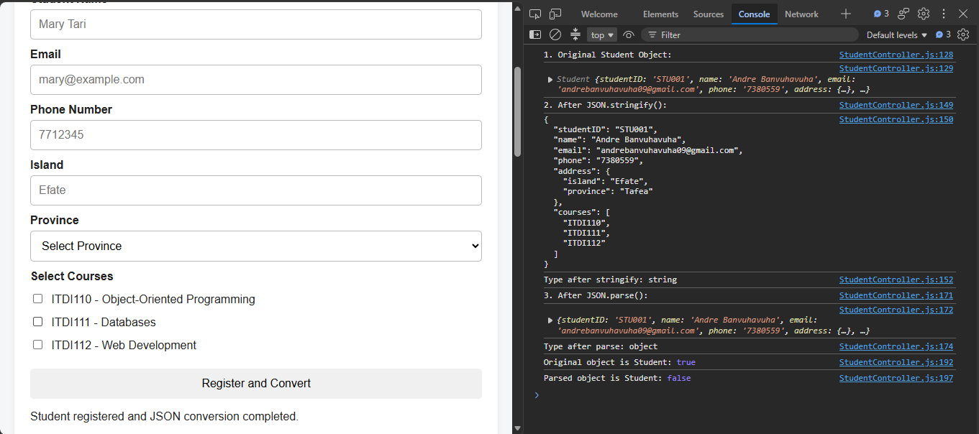

11. Activity B - Test Regular Expressions
Field | Test Input | Expected Result
Student ID | STU001 | Valid
Student ID | STU01 | Invalid
Name | Mary Tari | Valid
Name | Mary123 | Invalid
Email | mary@example.com | Valid
Email | mary@ | Invalid
Phone | 7712345 | Valid
Phone | 77123 | Invalid

12. Activity C - Create the Student Object
Enter this valid test record:
- Student ID: STU001
- Student Name: Mary Tari
- Email: mary@example.com
- Phone: 7712345
- Island: Efate
- Province: Shefa
- Courses: ITDI110 and ITDI111
Click Register and Convert. Observe the Original Student Object section and the browser Console. In the Console, student instanceof Student should be true. Notice that the Student class itself is now stored separately in js/model/Student.js.
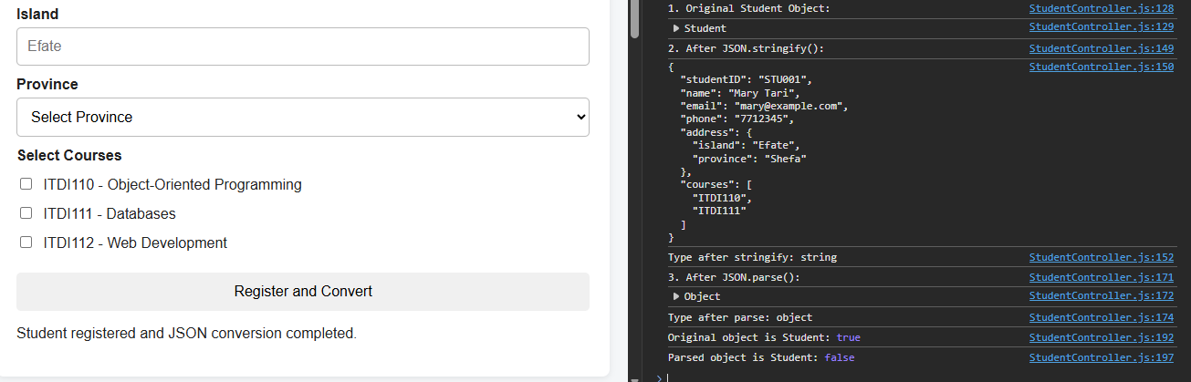

13. Activity D - Observe JSON.stringify()
The Controller executes:
const jsonString = JSON.stringify(student, null, 2);
- Observe that the student data is displayed as JSON text.
- Observe the line JavaScript type: string.
- In the Console, compare the original Student object with the JSON string.
Explain why JSON.stringify() is called serialization.
BEFORE:
Student class instance / JavaScript object

JSON.stringify()

AFTER:
JSON text
typeof jsonString === "string"
JSON.stringify() is called serialization because it converts a live JavaScript object (with properties and structure) into a plain text string in JSON format so that it can be stored, sent over a network, or saved to a file.
BEFORE:
Student class instance / JavaScript object

JSON.stringify()

AFTER:
JSON text
typeof jsonString === "string"

14. Activity E - Observe JSON.parse()
The Controller executes:
const parsedStudent = JSON.parse(jsonString);
- Observe that the JSON string is converted back into JavaScript data.
- Observe the line JavaScript type: object.
- In the Console, parsedStudent instanceof Student should be false.
- Explain why JSON.parse() is called deserialization.
JSON string

JSON.parse()

JavaScript object/data

typeof parsedStudent === "object"
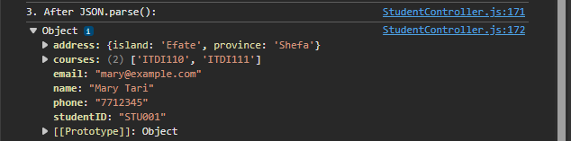
JSON.parse() is called deserialization because it takes the JSON text string and converts it back into a usable JavaScript object/data structure.

15. Activity F - Observe the OOP Effect
The original student was created with new Student(...), so it is an instance of the Student class and has access to displayProfile(). The object returned by JSON.parse() contains the data, but it is a plain JavaScript object. The Student class method is not preserved by ordinary JSON serialization.
student instanceof Student
// true

parsedStudent instanceof Student
// false

student.displayProfile()
// works

// parsedStudent.displayProfile()
// would fail because the parsed object does not have the class method

Student Task: In your own words, explain the difference between class behaviour and JSON data.
Class behaviour means the object has both data and methods that belong to the class (for example displayProfile()).

16. Activity G - Identify MVC Responsibilities
- Open js/model/Student.js. Identify the Student class, constructor, properties, nested address object, courses array and displayProfile() method.

- Open js/view/StudentView.js. Identify the DOM elements, clearErrors(), showError() and displayStudents().

- Open js/controller/StudentController.js. Identify validation, the submit event, new Student(...), JSON.stringify(), JSON.parse() and the download event.

Explain why separating these responsibilities makes the application easier to organise and maintain.
Separating the responsibilities into Model, View and Controller makes the application easier to organise and maintain because each part has a clear and single job:
- 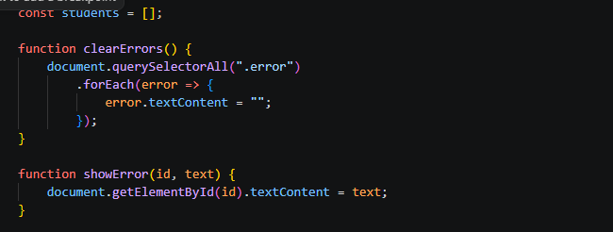

17. Activity H - Inspect Nested Object and Array
Find the address property in the JSON output. Explain why it is a nested object.
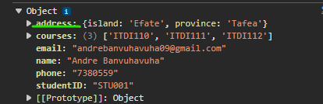
Because island and province belong together as one location.

Find the courses property. Explain why it is an array.
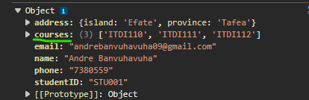
• Because a student can choose more than one course.
- •
- Identify the property names inside address.
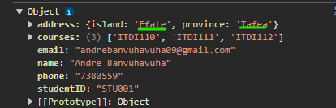
- Register a second student with a different province and different courses.
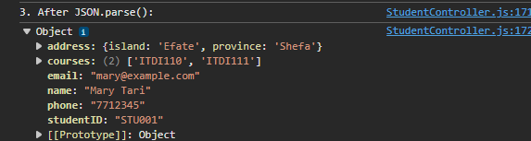

18. Activity I - Download students.json
- Register at least two valid students.
- Click Download students.json.
- Locate the downloaded students.json file.
- Open it in Visual Studio Code.
- Confirm that it contains an array of registered student objects.
Yes, it thus;
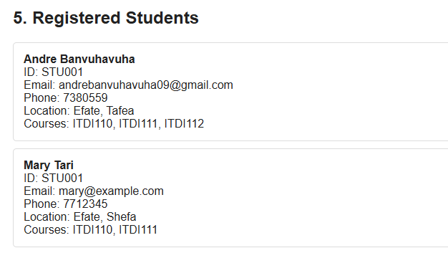
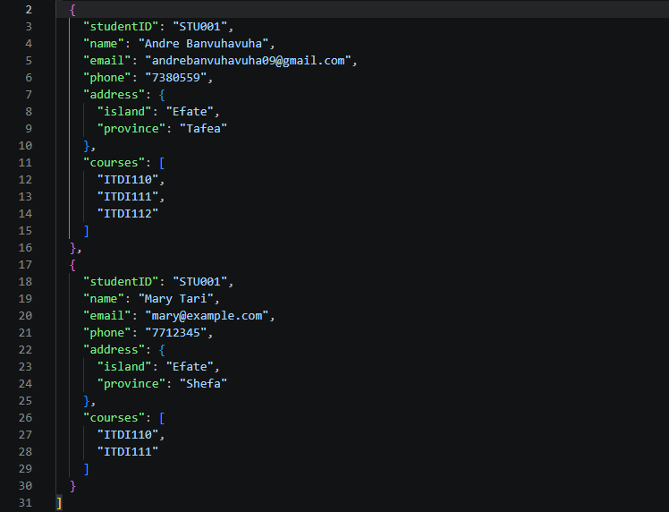

19. Final Comparison
Stage | Code | JavaScript Type | Meaning
Original | new Student(...) | object / Student instance | Object with data and class behaviour
Serialized | JSON.stringify(student) | string | JSON text ready for storage or transfer
Deserialized | JSON.parse(jsonString) | object | Plain JavaScript data object

20. MVC File Responsibilities
MVC Part | File | Main Responsibility
Model | js/model/Student.js | Student data structure and class behaviour
View | js/view/StudentView.js | DOM elements, errors and displaying registered students
Controller | js/controller/StudentController.js | Validation, events, object creation, JSON conversion and download

21. Final Testing Checklist
- The project contains separate html, css and js folders.
- The js folder contains model, view and controller subfolders.
- index.html loads ../css/style.css correctly.
- The scripts are loaded in the order Student.js, StudentView.js, StudentController.js.
- The form accepts valid student details.
- Invalid Student ID, name, email and phone values are rejected.
- A Student class instance is created.
- JSON.stringify() produces a string.
- JSON.parse() produces a JavaScript object.
- The original Student instance and parsed object are visibly compared.
- The nested address object appears correctly.
- The courses array appears correctly.
- students.json downloads successfully.
- The page remains usable on a mobile-sized screen.

22. Reflection Questions
What does JSON.stringify() do?
It converts a JavaScript object into a JSON text string.

Why is the result of JSON.stringify() a string?
Because JSON is a text format used for storing or sending data.

What does JSON.parse() do?
It converts a JSON text string back into a JavaScript object.

What is the difference between serialization and deserialization?
Serialization turns an object into text. Deserialization turns the text back into an object.

Why is student instanceof Student true?
Because it was created with new Student(...).

- Why is parsedStudent instanceof Student false?
Because JSON.parse() only creates a plain object, not a Student class instance.

- Why is displayProfile() not stored in ordinary JSON?
Because JSON only stores data, not functions or methods.

Why is address represented as a nested object?
Because island and province belong together as one location.

Why are courses represented as an array?
Because a student can select more than one course.

What is the responsibility of the Model in this application?
To store the Student data and class behaviour.

What is the responsibility of the View?
To display information and errors on the webpage.

What is the responsibility of the Controller?
To handle validation, events, object creation and JSON conversion.

Why must the JavaScript files be loaded in Model -> View -> Controller order in this lab?
Because the Controller needs the Student class from the Model to work.

Give one real application where JSON could be used to transfer data.
Sending student registration data from a website to a server.

23. Submission Requirements
Submit the complete student-registration_lab9 folder containing the html, css and js folders. The js folder must contain the model, view and controller subfolders with their respective files. Also submit the generated students.json file containing at least two valid student records and the reflection question answer.
student-registration_lab9/
|-- html/
| `-- index.html
|-- css/
| `-- style.css
`-- js/
|-- model/
| `-- Student.js
|-- view/
| `-- StudentView.js
`-- controller/
`-- StudentController.js

Plus:
students.json
reflection question

THE END!

